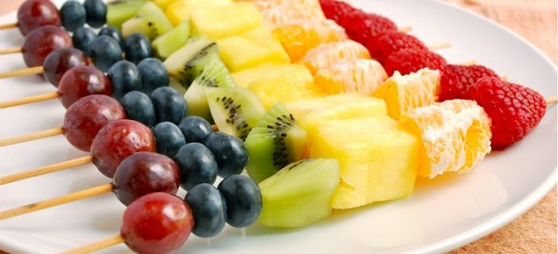

**Rainbow Fruit Skewers**

**Ingredients:**

* **12 raspberries**
* **6 orange segments (from 1 large orange), cut in half**
* **12 1” chunks of pineapple**
* **1 large kiwi, peeled and cut into 12 1” chunks**
* **24 large blueberries**
* **12 red seedless grapes**

**Method:**

**Lay out 12 bamboo skewers. Prepare your fruit. Slide a raspberry to the top of the stick, next add chunks of orange, pineapple, kiwi, 2 blueberries, and a grape. Repeat for each skewer.**